American Highland Cattle Association

Bagpipe Advertising Contract

Name:

Farm or Business Name:

Address:

Phone:

Email:

Signature:

The Bagpipe has been featuring your ________ page ad ________ a year.

Please run my ad in the following issues: Winter 14 Spring 14 Summer 14 Fall 14

I have enclosed: _____ full payment ______ 1st issue’s payment
(AHCA will charge credit card prior
to each issue; receipt serves as notice.)

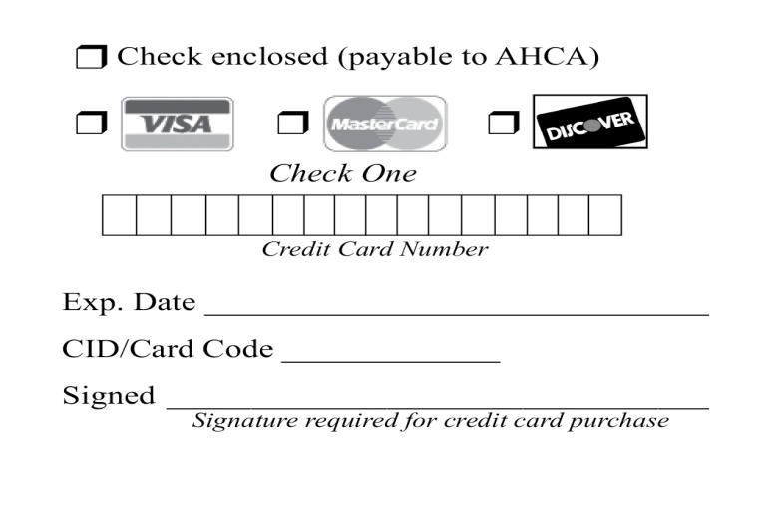

Advertising Schedule
Issue | Deadline | Publication
Winter | November 1 | January
Spring | February 1 | April
Summer | May 1 | July
Fall | August 1 | October

Please fill out the contract completely and send with payment by November 1, 2013 to:
AHCA - Historic City Hall, 22 S. 4th Ave., Ste. 201, Brighton, CO 80601-2030

Breeder Advertising Space Rates
(Black and White)

Size | Single Issue | 4-Time Contract
Back Cover (7 ¾ x 6 ½ ) | $265 | $975
Inside Front Cover (7 ¾ x 10 ¼) | $265 | $975
Inside Back Cover (7 ¾ x 10 ¼) | $265 | $975
Premium Page (7 ¾ x 10 ¼) | $265 | $975
Full Page (7 ¾ x 10 ¼) | $225 | $830
2/3 Page | $175 | $650
1/2 Page | $140 | $520
1/3 Page | $100 | $375
1/6 Page | $60 | $216
The 4-time rate is for four consecutive issues and must be prepaid before the first issue is printed
or AHCA will charge your credit card prior to each issue; receipt serves as notice.
These rates are for AHCA members. All others add 25%.

Color Rates (Additional)

4 – color process: $125 additional per issue.

Spot color added to a black and white ad, per issue, full or partial: $50.00/standard color.

Ad Setup and Change Rates (Additional)
- Ad setup: $150 for 2/3 or full page; $75 ½ page or less.
Ad setup for a camera-ready ad: $60 for 2/3 or full page; $30 ½ page or less.
- Ad changes
Photo only: $40 for 2/3 or full page; $20 ½ page or less.
Text only: $40 for 2/3 or full page; $20 ½ page or less.

Add $60 per page to space rate when requesting color or black bleeds into ad margins.

Add 10% when requesting use of a reverse in ad.

Closing Dates

All advertising copy (including photos) must be in this AHCA office by the 1st of the month preceding publication. (i.e., May 1 for June 1 publication). Although we devote the utmost care to the preparation of each advertising insertion, we cannot be responsible for errors made when copy is received after the deadline or by phone.

Terms

All advertising accounts are due and payable as invoiced. Interest charges of 1.5% per month (18% annual interest rate) will be assessed to accounts 30 days past due.

Advertising Content

The Bagpipe reserves the right to refuse any advertising or copy at its sole discretion. The Bagpipe assumes no responsibility for the accuracy of the advertising content as submitted. Advertisers assume all responsibility for the accuracy and truthfulness of submitted advertising containing pedigrees, statements regarding performance, etc.

Editorial Content

All rights reserved by The Bagpipe and the American Highland Cattle Association. No part of this publication may be transmitted or reproduced in any form, electronic or mechanical, without permission from the editor. Opinions expressed are those of the writer and not necessarily those of the American Highland Cattle Association. Photographs and manuscripts are welcome but no responsibility is assumed for such material while in transit or while in the editorial office.

